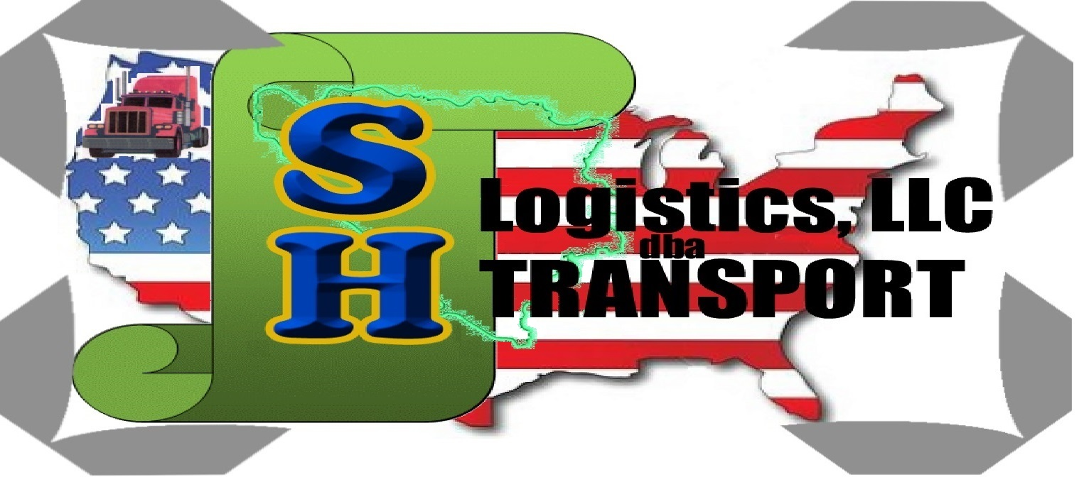
SH Logistics, LLC dba SH Transport
11102 E Harvard dr Aurora CO 80014
Phone Number :303-719-9521 |^^^^^^^^^^^^^^| || \
Phone Number :330-737-7702 | SH Transport ||'|";,
Fax Number :303 337-2039 |_..._..._______===|=||_|__|..., ] -
E-fax :866-237-1349 "(@)'(@)"""''"**|(@)(@)*****''(@)
Email :nihadp@shlogisticsllc.com

Driver: _____________________SSN:_______________________Date:___________

Company: _______________________________________________________________

_______________________________________Ph:______________________
Period of Service Detail:
Start Date 1: _________ Start 2: _________ Start 3: _________ Miles / Week: _________

End Date 1: _________ End 2:_________ End 3: _________ Hours / Week: _________

Position(s) Held: _______________________________ Reason(s) for leaving ____________________________________
Driver Class: Type: Truck: Subject to FMCSRs? Subject to DOT D&A?
Company: ____ Solo: ____ Tractor-Trailer: ____ Yes: _______ Yes: _______
Lease: ____ Team: ____ Straight Truck: ____ No: _______ No: _______
Own/Op: ____ Student: ____ Other: ____
Other: ____ Other: ____

Eligible for rehire? Experience: Responsible for Area Driven:
Yes ____ Flatbed: ____ Maintaining logs? OTR _____
No ____ Van: ____ Yes ____ Regional _____
Review ____ Reefer: ____ No ____ Local _____
Intermodal: ____ Other _____
Terminated? Snow / Ice: ____
Yes ____ Other: ____ # Of States Driven: _____
No ____

Loads Hauled: _________________________ Trailer Length: ___________
Accidents: (if none, enter zero) Preventable: ____ #Non-Preventable: ____ # DOT Reportable: ____
Date City, State Description #Fatalities #Injuries Hazmet? Preventable?

Drug and Alcohol (to be accompanied by an appropriate drug and alcohol release)
In the three years prior to the date of the employee’s signature (on the release), for DOT-regulated testing:
- Did the employee have alcohol tests with a result of 0.04 or higher? Yes No
- Did the employee have verified positive drug tests? Yes No
- Did the employee refuse to be tested? Yes No
- Did the employee have other violations of DOT agency Drug and Alcohol testing regulations? Yes No
- Did a previous employer report a drug and alcohol rule violations to you? Yes No
- If you answered “yes” to any of the above items, did the employee complete the return-to-duty process? Yes No
NOTE: If you answered “yes” to item 5, you must provide the previous employer’s report. If you answered “yes” to item 6, you must also transmit the appropriate return-to-duty documentation (e.g., SAP report(s), follow-up testing record).

______________________________ ________________________________ ___________________________________
Info provided by (signature): Title, Date Phone

___________________________ _____________________________ _______________________________
Printed Name Company DOT# Email

Comments: _____________________________________________________________________________
SH Logistics, LLC dba SH Transport
11102 E Harvard dr Aurora CO 80014
Phone Number :303-719-9521 |^^^^^^^^^^^^^^| || \
Phone Number :330-737-7702 | SH Transport ||'|";,
Fax Number :303 337-2039 |_..._..._______===|=||_|__|..., ] -
E-fax :866-237-1349 "(@)'(@)"""''"**|(@)(@)*****''(@)
Email :nihadp@shlogisticsllc.com

Fax Verification Request

To: _____________________________ From: ___________________________

ATTN: __________________________ Date: ___________________________

RE: ____________________________ SSN: ____________________________

Please return this cover sheet pr page two with your response.
We use the barcode to identify the driver in our systems. Thank You!

Notes:

We have your fax#as . Please email us if you’d prefer that we use a different number for verifications.

SH Logistics, LLC dba SH Transport
11102 E Harvard dr Aurora CO 80014
Phone Number :303-719-9521 |^^^^^^^^^^^^^^| || \
Phone Number :330-737-7702 | SH Transport ||'|";,
Fax Number :303 337-2039 |_..._..._______===|=||_|__|..., ] -
E-fax :866-237-1349 "(@)'(@)"""''"**|(@)(@)*****''(@)
Email :nihadp@shlogisticsllc.com

Driver Authorization to Release Records

Consumer Report Disclosure and Release

In Connection with your employment or application for employment (including contract for services) with SH Logistics, LLC dba SH Transport, consumer reports may be requested from USIS commercial Services (USIS). These reports may include the following types of information: names and dates of previous employers, reason for termination of employment, work experience, accidents, academic history, professional credentials, and drugs/alcohol use. Such reports may contain public record information concerning your driving record, workers compensation claims, credit, bankruptcy proceedings, criminal records, etc., from federal, state and other agencies which maintain such records; as well as information from USIS concerning previous driving record requests made by others from such state agencies and state provided driving records.

You have the right to make a request to USIS, upon proper identification, to request the nature and substance of all information in its files on you at the time of your request, including the source of information and the recipients of any reports on you that USIS has previously furnished within the three-year period preceding your request. USIS may be contacted by mail at P.O Box 33181, Tulsa, Oklahoma, 74153, or by phone at (800)381-0645.

I AUTHORIZE, WITHOUT RESERVATION, USIS, AND PARTY OR AGENCY CONTACTED BY USIS, TO FURNISH THE ABOVE-MENTIONED INFORMATION. THIS AUTHORIZATION DOES NOT APPLY TO DRUG AND ALCOHOL INFORMATION OBATINED UNDER PART 1.

I hereby consent to your obtaining the above information from USIS, and I agree that such information which USIS has or obtains, and my employment history (not DOT Drug and Alcohol information without a specific consent by me) with you if I am hired will be supplied by USIS to other companies which subscribe to USIS. I hereby authorize procurement of consumer report(S). if hired or contracted, this authorization, for reports covered by this release only, shall remain on file and shall serve as ongoing authorization for you to procure consumer reports at any time during my employment or contract period.

Notice to California Applicants

Under California law, the consumer reports we order on you for employment purposes within the State Of California are defined as investigative consumer reports. These reports may contain information on your character, general reputation, personal characteristics and mode of living. Under section 1786.22 of the California Civil Code, you may view the file maintained on you by USIS during normal business hours. You may also obtain a copy of this file upon submitting proper identification and paying the costs of duplication services, by appearing at USIS in person or by mail, The agency is required to have personnel available to explain your file to you and the agency must explain to you any coded information appearing in your file. If you appear in person, a person of your choice may accompany you, provided that this person furnished proper identification.

Printed Name: SIGNATURE Name

Social Security# Address and Ph #

Signed Date:

